- On your Windows laptop or PC, open 'System Information' and take a screenshot showing your OS version, processor, and RAM details.
Ans : - • Press Windows + R on your keyboard.
• Type msinfo32 and press Enter.
• The System Information window will open.
• Click System Summary.
• Find these details:
- OS Name: Windows version installed.
- Version: Windows version/build information.
- Processor: CPU model.
- Installed Physical Memory (RAM): Total RAM installed.
• Take a screenshot by pressing Windows + Shift + S.
• Save the screenshot and attach it to your practical assignment.
- System Information was opened to check the operating system, processor, and RAM details.

- Download any official Linux distribution ISO (like Ubuntu or Fedora), and use Rufus or BalenaEtcher to create a bootable USB drive for installation.<br><br><em><strong>Hint:</strong> If you don't have a spare USB, use a virtual machine tool like VirtualBox to mount the ISO and start the installation process virtually.</em>
Ans : - To download a Linux ISO file and prepare installation media.
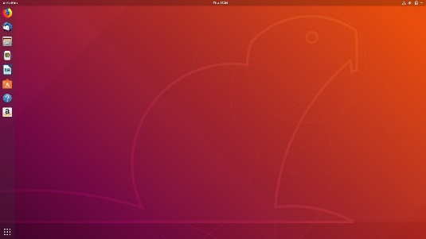
Step 1: Download Ubuntu
Open the official website: Ubuntu Desktop Download.
Download the Ubuntu ISO file.
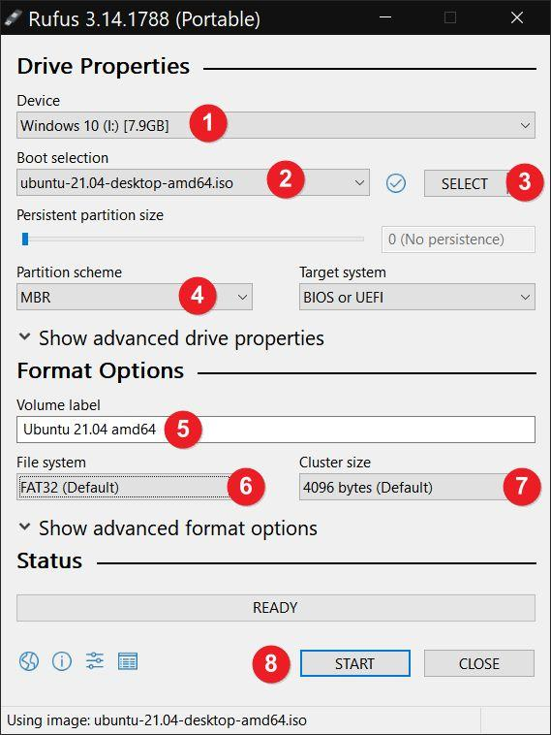
Step 2: Download Rufus
Open Rufus official website and download Rufus.
Step 3: Create the bootable USB
- Connect a USB drive of at least 8 GB.
- Open Rufus.
- Select your USB drive under Device.
- Click SELECT and choose the Ubuntu ISO.
- Keep the recommended settings unless you need specific compatibility settings.
- Click START and confirm the prompts.
- Wait until Rufus finishes.
Warning: Creating the bootable USB will erase the data on the selected USB drive. Back up your files first.
Alternative without a USB: Install Oracle VirtualBox. Create a new virtual machine, select the Ubuntu ISO as its virtual optical disk, and start the machine.
- A bootable Ubuntu USB drive or a virtual machine ready to start Ubuntu installation was prepared.

- On a macOS device (or using a macOS virtual machine), open 'System Preferences' and change the desktop wallpaper, then adjust the system language to Hindi or Gujarati.<br><br><em><strong>Hint:</strong> Find 'Language & Region' in System Preferences to add or change languages.</em>
Ans :- To change the desktop wallpaper and set the system language to Hindi or Gujarati.
Steps:
- Turn on your Mac and sign in.
- Open the Apple menu ().
- Open System Preferences on older macOS versions, or System Settings on newer versions.
- Select Desktop & Screen Saver or Wallpaper.
- Choose a new wallpaper.
- Open Language & Region.
- Click the + button to add a language.
- Select Hindi or Gujarati.
- If prompted, choose to use the selected language as the primary language.
- Log out and log in again, or restart if required, to apply the change.

- The desktop wallpaper was changed and the system language was set to the selected language.

- Install a fresh copy of Ubuntu Linux (real or virtual machine) and create a new user account named 'gamer'. After installation, enable automatic login for this user and take a screenshot of the login screen showing the username.
Ans :- To install Ubuntu, create a new user account, and enable automatic login.
Steps:
- Start Ubuntu using the bootable USB or VirtualBox.
- Select Install Ubuntu.
- Choose your language and keyboard layout.
- Select the installation type and follow the on-screen instructions.
- When asked for your account details, enter:
  - Your name: Gamer
  - Username: gamer
  - Password: Create a strong password.
- Complete the installation and restart Ubuntu.
- Log in with the gamer account.
- Open Settings.
- Go to System → Users or Users, depending on the Ubuntu version.
- Click Unlock and enter your password if required.
- Select the gamer account and enable Automatic Login.
- Restart the computer to verify the setting.
- Ubuntu was installed, the gamer account was created, and automatic login was enabled.

- Use ChatGPT to generate a step-by-step guide for installing Windows 10 on a laptop, including partitioning tips and post-installation settings for privacy and updates. Follow the guide and note any steps that were unclear or missing.
Ans :- To install Windows 10, understand disk partitioning, configure privacy settings, and check updates.
Important: Windows 10 support ended on October 14, 2025. For a computer used regularly, Microsoft recommends upgrading to a supported version of Windows, such as Windows 11, if the computer is compatible.

A. Requirements
- A laptop or PC that meets Windows 10 system requirements.
- A USB drive with at least 8 GB of storage.
- A Windows 10 ISO or installation media from the official Microsoft website.
- A valid Windows licence, if required.
- A backup of important files.

B. Installation steps
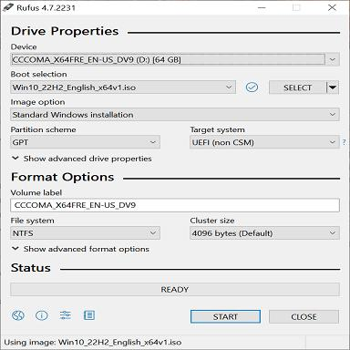
Step 1: Create installation media
Download the Windows 10 installation media from Microsoft. Follow the instructions to create a bootable USB drive. This process erases the USB drive.
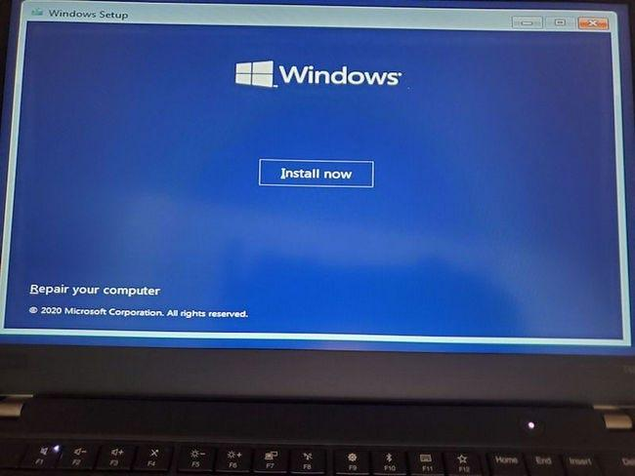
Step 2: Boot from USB
Connect the USB, restart the PC, and open the boot menu using the manufacturer's key (often F12, F9, Esc, or another key). Select the USB drive.
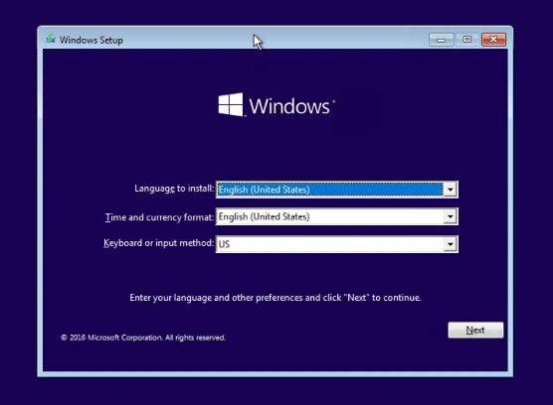
Step 3: Start setup
Choose the language, time format, and keyboard layout. Click Next → Install now.
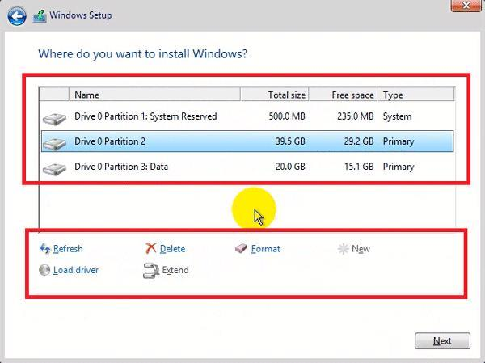
Step 4: Select the installation type
Enter the product key if requested, select the appropriate Windows edition, accept the licence terms, and choose Custom: Install Windows only for a clean installation.
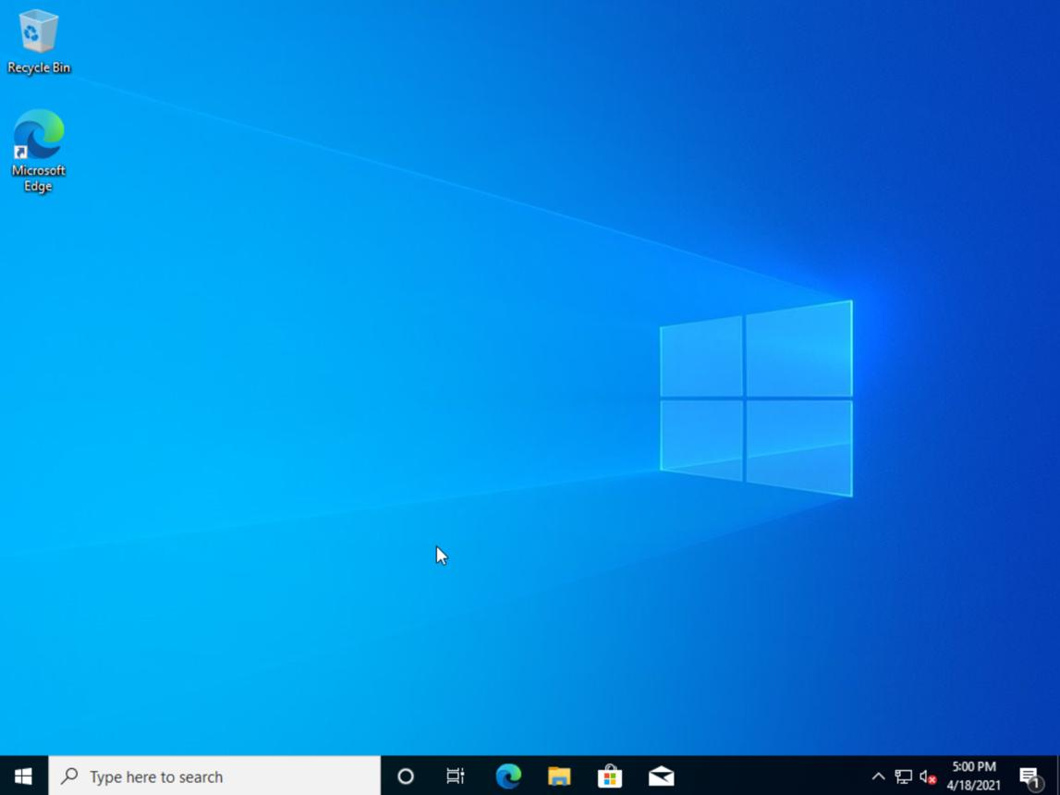
Step 5: Complete installation
Select the correct installation drive and partition, then continue. The PC will restart. Follow the setup prompts to configure your region, keyboard, account, and network.

C. Disk partitioning tips
- Back up files first: A clean installation can erase files and applications.
- Identify the correct drive: Check drive capacity carefully before selecting a partition.
- Avoid deleting partitions blindly: Recovery and manufacturer partitions may be important.
- For a clean installation: Only delete or format partitions when you understand which drive they belong to and have backed up all needed data.
- For a virtual machine: Use a virtual disk so your existing computer's partitions are not changed.

D. Privacy settings after installation
- Open Settings → Privacy.
- Review the permissions for location, camera, microphone, and other apps.
- Turn off permissions that apps do not need.
- Review diagnostic data and advertising-related settings.
- Use a strong account password and enable a screen lock.
- Keep Windows Firewall and antivirus protection enabled.

E. Check updates and drivers
- Open Settings → Update & Security → Windows Update.
- Select Check for updates.
- Install any updates offered for your system.
- Visit the laptop manufacturer's official support website to check for required drivers.
Remember that Windows 10 no longer receives regular security updates after its support ended, unless the device is covered by an applicable extended security update programme.

F. What I learned / unclear steps
You can use the following sample reflection for your assignment and adjust it to match your actual experience.
- I learned how to create a bootable USB drive and start Windows installation.
- I learned that disk partitioning must be done carefully to prevent data loss.
- I learned how to review privacy settings and check for updates.
- The boot-menu key was unclear because it differs between computer manufacturers.
- Selecting the correct partition was the most important step because formatting the wrong partition can delete data.

